Unit 9: CITIES OF THE WORLD
I. Find the word which has a different sound in the part underlined
1. A.  2. A.  3. A.  4. A.  5. A.  6. A.  7. A.  8. A.  9. A.  10. A. | like  postcard  motor  find  wish  hear  high  show  fast  photo | B.  B.  B.  B.  B.  B.  B.  B.  B.  B. | delicious  come  money  write  price  speak  dish  slow  visit  continent | C.  C.  C.  C.  C.  C.  C.  C.  C.  C. | nice  home  show  design  high  clean  fish  tower  fantastic  popular | D.  D.  D.  D.  D.  D.  D.  D.  D.  D. | fine  so  robot  typical  mind  beach  city  motor  postcard  coffee

II. Find the word which has a different word stress:
1. A. fantastic | B. typical | C. popular | D. wonderful
2. A. tower | B. design | C. photo | D. title
3. A. understand | B. performance | C. polite | D. exciting
4. A. prepare | B. historic | C. symbol | D. pogoda

III. Put the words into two groups (/əʊ / and /aI/)
minor  show | slow  type | price  motor | design  shy | title  judo | fine  right | pagoda  poem | drive  robot | postcard  behind

/əʊ / | /aI/

IV. Find which word does not belong to each group.
1. A.  2. A.  3. A.  4. A.  5. A. | peaceful  Africa  tea  beautiful  clock | B.  B.  B.  B.  B. | beautiful  Sweden  television  wonderful  bell | C.  C.  C.  C.  C. | noise  America  sandwich  fantastic  tower | D.  D.  D.  D.  D. | delicious  Asia  hamburger  boring  lion

V. Give the names of the following landmarks (the first letter of each word is given).
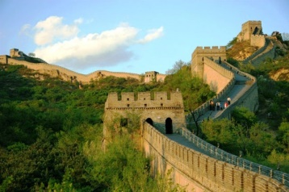 | 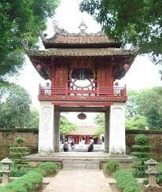 | 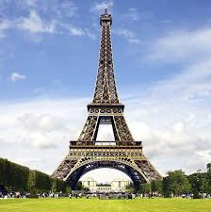 | 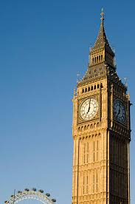
1.G_____________ | 2. T______________ | 3. E______________ | 4. B______________

VI. Give the antonyms of the adjectives into the box under them. Then put the right superlatives of long adjectives in each space to complete the following sentences.
adjective | awful | cheap | boring | safe | historic | ugly
antonym | delicious

1. Pho is the most delicious food.
2. My family had a lot of fun in Ha Noi. It is trip.
3. I want to visit Italy in the future because it is country.
4. People must be well-prepare when they visit the Amazon River, one of the __________ places in the world.
5. Amsterdam High School is school in Viet Nam with high-tech facilities.
6. Japan is one of countries in the world. It costs you a lot of money to live there.

VII. Match the questions (A) and the answers (B).
A | B
1.___ What’s the weather in Ha Long Bay like?  2.___ What will Hoa do tomorrow?  3.___ Is the weather here hotter than in Singapore?  4.___ What have Phong and Lan done?  5.___ What do you think about the local people? | a. The sun is shining all the time.  b. She’ll visit the Big Ben.  c. They are very friendly.  d. I think they are the same.  e. They have visited the Old Quarter.

VIII. Choose the best answer (A, B, C or D).
1. The Eiffel tower is the most landmark in the world.
A. visit | B. visiting | C. visited | D. to visit
2. When we were in Stockholm, we had coffee and cakes a coffee shop the old town.
A. on – on | B. at – at | C. in – in | D. on – at
3. - Do you know the most drink in Vietnam?
A. popular | B. cheap | C. hot | D. best
4. People in Tokyo are very polite friendly.
A. or | B. but | C. so | D. and
5. Have you ever to Manchester?
A. be | B. been | C. being | D. went
6. I think it is a very nice town the weather is good and the people are friendly.
A. because | B. if | C. so | D. although
7. This is the first time that I a 3d film.
A. watch | B. watched | C. watches | D. have watched
8. I Da Lat three times in all.
A. visit | B. visited | C. visiting | D. have visited
9. The red double-decker bus is London’s famous .
A. sign | B. signal | C. symbol | D. logo
10. Which is Britain in? – Europe.
A. country | B. continent | C. city | D. area
11. People must be well-prepared they want to climb Mount Everest.
A. after | B. until | C. although | D. before
12. The food is .
A. noisy | B. delicious | C. friendly | D. quiet
13. International school in Ho Chi Minh City is the school in Vietnam with high-tech facilities.
A. oldest | B. youngest | C. most historic | D. most modern
14. My family had a lot of in Hoi An and it was an exciting trip.
A. fun | B. funny | C. enjoy | D. enjoys
15. That city is most famous its fashion shops.
A. to | B. with | C. for | D. of
16. Do you have in Da Lat during your holiday?
A. time | B. good time | C. a good time | D. good a time
17. Nha Trang has an atmosphere of young, city.
A. exciting –  growing | B. exciting –  grown | C. excited –  grow | D. excited –  growing
18. I have been to Nha Trang . How about you?
A. one | B. two | C. two times | D. twice
19. Britain’s most common activities are watching TV and films and listening to the radio.
A. free | B. leisure | C. good | D. popular
20. Big Ben is the most famous in England.
A. tower | B. waterfall | C. city | D. river

IX. Complete the following sentences with the correct words from the box.
 | not see | take | visit | win | read | not study
1. My team ten matches this year.
2. They German before. This is their first year.
3. I lots of photos with my camera.
4. She the USA three times. Her aunt lives there.
5. The longest book I is The Lord of the Rings.
6. I that film. Is it good?

X. Put the verbs in the brackets in the Present Perfect tense.
1. I (have) this bike since I was a teenager and I still use it.
2.The weather (be) quite good since Christmas.
3. I (study) very hard for this examination.
4. He (play) for the football club for several years, but it’s time to leave it now.
5. Mike and his brother (learn) English for three years.
6. Mr. Brown (play) chess since eight o’clock.
7. It (not rain) since last week.
8. We (not see) our new teacher yet.
9. My aunt (work) in this hospital for eleven years.
10. She (see) the film before.

XI. Put the verbs in brackets in the correct verb tense.
1. Be careful. The teacher (look) at you.
2. Our school performance (start) late last Sunday because of the heavy rain.
3. The boy (learn) for three years, but he can’t understand this letter.
4. Would you like some coffee? I (just/ make) some.
5. (she/ feed) the cat yet?
6. (your dog/ ever bite) anyone?
7. (you/ ever be) to Ha Noi?

